Project Development Phase
Performance Test

Date | 03 October 2026
Team ID | SWTID-2026-5003
Project Name | Implement Client Script and UI Policy (Incident)
Maximum Marks | Not specified

Model Performance Testing:
Prepared for the project team. The report uses available configuration screenshots; no formal performance measurements or signed test results were supplied. Team: Kaleeswari G (Team Leader: Milestones 4 and 5, Milestone 6 Activity 1); Devibala. A. S (Milestones 1 to 3); Karthika. M (Milestone 6 Activities 2 to 4); Amirtha Varshini S (Milestone 6 Activity 5 and conclusion).
S.No. | Parameter | Screenshot / Values
1. | Data Rendered | No Tableau data source or workbook is included. The project evidence shows ServiceNow Incident records/forms.  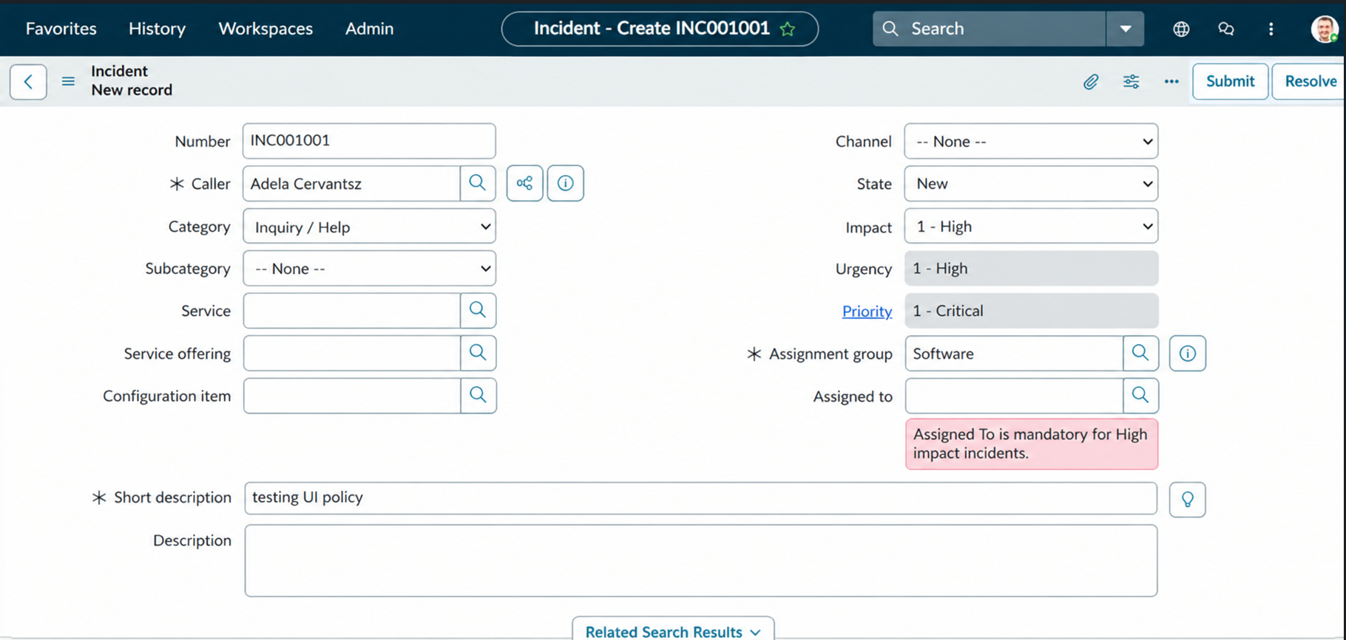
2. | Data Preprocessing | No Tableau data preparation is performed; the project configures form behavior.  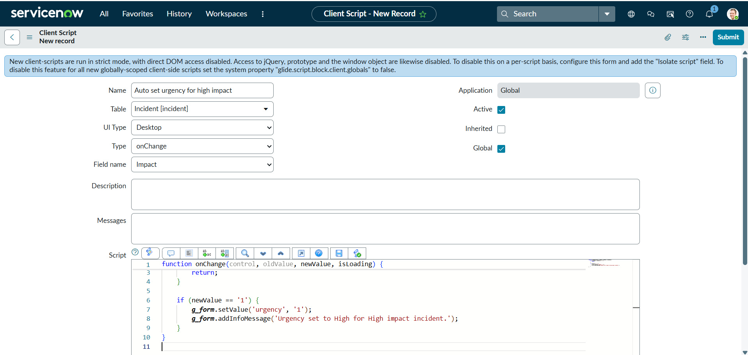
3. | Utilization of Filters | No Tableau filters are used. Related condition: Impact = 1 (High) in the UI Policy.  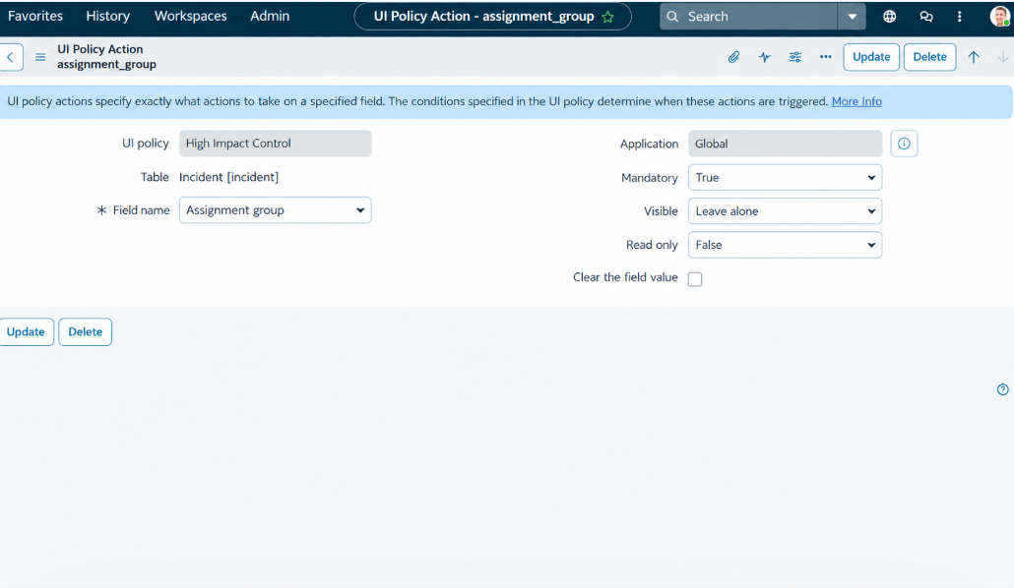
4. | Calculation fields Used | No Tableau calculated fields are included; Client Scripts use JavaScript and g_form.
5. | Dashboard design | Not applicable: this ServiceNow project has no Tableau dashboard or visualization count.
6. | Story Design | Not applicable: no Tableau story is included.

